

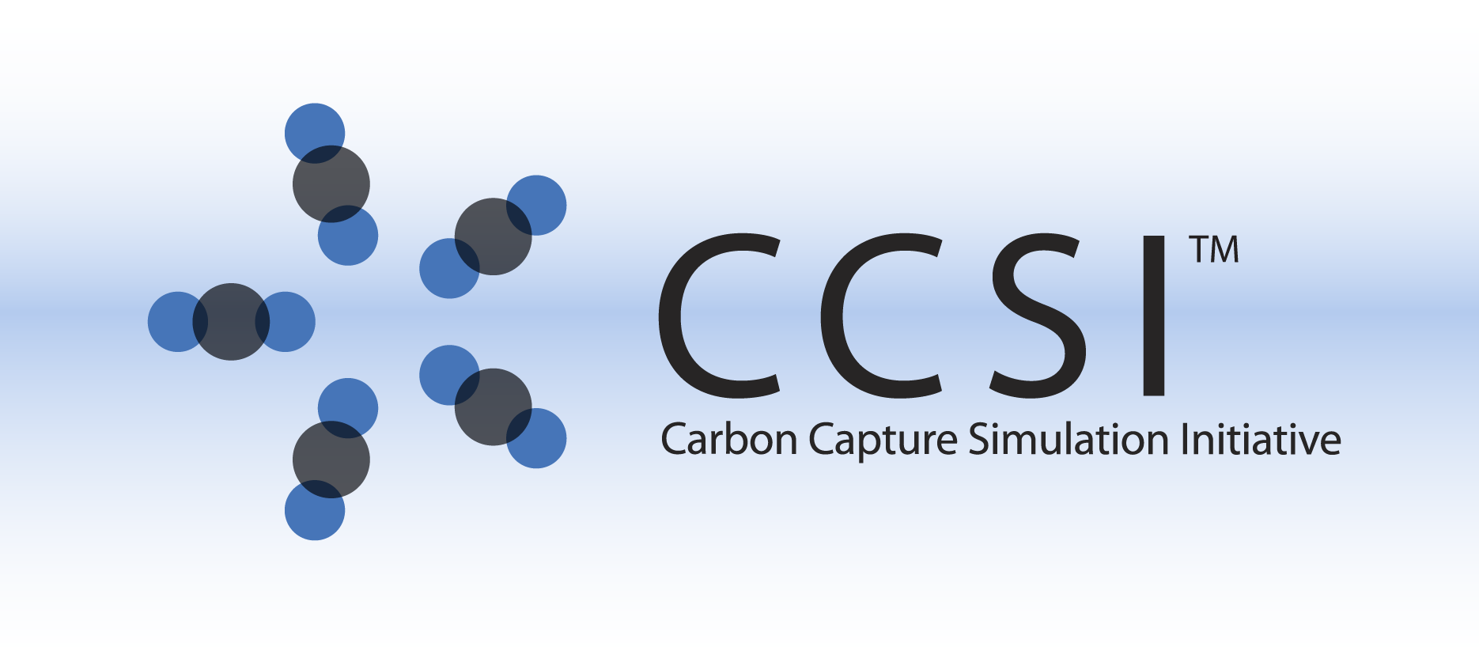

CCSI Pulverization Model

User Manual

Version 2.0.0

March 2018



Copyright (c) 2012 - 2018

**Copyright Notice**

Pulverization Model was produced under the DOE Carbon Capture Simulation Initiative (CCSI), and is copyright (c) 2012 - 2018 by the software owners: Oak Ridge Institute for Science and Education (ORISE), Los Alamos National Security, LLC., Lawrence Livermore National Security, LLC., The Regents of the University of California, through Lawrence Berkeley National Laboratory, Battelle Memorial Institute, Pacific Northwest Division through Pacific Northwest National Laboratory, Carnegie Mellon University, West Virginia University, Boston University, the Trustees of Princeton University, The University of Texas at Austin, URS Energy & Construction, Inc., et al.. All rights reserved.

NOTICE. This Software was developed under funding from the U.S. Department of Energy and the U.S. Government consequently retains certain rights. As such, the U.S. Government has been granted for itself and others acting on its behalf a paid-up, nonexclusive, irrevocable, worldwide license in the Software to reproduce, distribute copies to the public, prepare derivative works, and perform publicly and display publicly, and to permit other to do so.

**License Agreement**

Pulverization Model Copyright (c) 2012 - 2018, by the software owners: Oak Ridge Institute for Science and Education (ORISE), Los Alamos National Security, LLC., Lawrence Livermore National Security, LLC., The Regents of the University of California, through Lawrence Berkeley National Laboratory, Battelle Memorial Institute, Pacific Northwest Division through Pacific Northwest National Laboratory, Carnegie Mellon University, West Virginia University, Boston University, the Trustees of Princeton University, The University of Texas at Austin, URS Energy & Construction, Inc., et al. All rights reserved.

Redistribution and use in source and binary forms, with or without modification, are permitted provided that the following conditions are met:

1. Redistributions of source code must retain the above copyright notice, this list of conditions and the following disclaimer.
2. Redistributions in binary form must reproduce the above copyright notice, this list of conditions and the following disclaimer in the documentation and/or other materials provided with the distribution.
3. Neither the name of the Carbon Capture Simulation Initiative, U.S. Dept. of Energy, the National Energy Technology Laboratory, Oak Ridge Institute for Science and Education (ORISE), Los Alamos National Security, LLC., Lawrence Livermore National Security, LLC., the University of California, Lawrence Berkeley National Laboratory, Battelle Memorial Institute, Pacific Northwest National Laboratory, Carnegie Mellon University, West Virginia University, Boston University, the Trustees of Princeton University, the University of Texas at Austin, URS Energy & Construction, Inc., nor the names of its contributors may be used to endorse or promote products derived from this software without specific prior written permission.

THIS SOFTWARE IS PROVIDED BY THE COPYRIGHT HOLDERS AND CONTRIBUTORS "AS IS" AND ANY EXPRESS OR IMPLIED WARRANTIES, INCLUDING, BUT NOT LIMITED TO, THE IMPLIED WARRANTIES OF MERCHANTABILITY AND FITNESS FOR A PARTICULAR PURPOSE ARE DISCLAIMED. IN NO EVENT SHALL THE COPYRIGHT OWNER OR CONTRIBUTORS BE LIABLE FOR ANY DIRECT, INDIRECT, INCIDENTAL, SPECIAL, EXEMPLARY, OR CONSEQUENTIAL DAMAGES (INCLUDING, BUT NOT LIMITED TO, PROCUREMENT OF SUBSTITUTE GOODS OR SERVICES; LOSS OF USE, DATA, OR PROFITS; OR BUSINESS INTERRUPTION) HOWEVER CAUSED AND ON ANY THEORY OF LIABILITY, WHETHER IN CONTRACT, STRICT LIABILITY, OR TORT (INCLUDING NEGLIGENCE OR OTHERWISE) ARISING IN ANY WAY OUT OF THE USE OF THIS SOFTWARE, EVEN IF ADVISED OF THE POSSIBILITY OF SUCH DAMAGE.

You are under no obligation whatsoever to provide any bug fixes, patches, or upgrades to the features, functionality or performance of the source code ("Enhancements") to anyone; however, if you choose to make your Enhancements available either publicly, or directly to Lawrence Berkeley National Laboratory, without imposing a separate written license agreement for such Enhancements, then you hereby grant the following license: a non-exclusive, royalty-free perpetual license to install, use, modify, prepare derivative works, incorporate into other computer software, distribute, and sublicense such enhancements or derivative works thereof, in binary and source code form. This material was produced under the DOE Carbon Capture Simulation

Table of Contents

CCSI CFD Models 1

1.0 Abstract 1

2.0 Reporting Issues 1

3.0 Version Log 1

MFIX-DEM Pulverization Model 2

1.0 Installation 2

1.1 Prerequisites 2

1.2 Third Party Software 2

1.3 Product Installation 2

2.0 Simulations 3

3.0 References 4

4.0 [1] MFIX – Multiphase Flow with Interphase eXchanges, Version MFIX-2012-1, January 2012. (The readme.pdf is distributed within the MFIX tar ball.) 4

List of Figures

Figure 1: Transient load response (Intel Fortran compiler used). 4

To obtain support for the products within this package, please send an e-mail to   
[ccsi-support@acceleratecarboncapture.org](mailto:ccsi-support@acceleratecarboncapture.org).

CCSI CFD Models

1. Abstract

CCSI Attrition and Pulverization Model: Particle attrition is frequently encountered during the processing and handling of mesoporous particles in chemical processing, where the particles suffer progressive loss of material as a result of collisions and friction. In fluidized bed reactors, particle size reduction due to attrition can result in agglomeration and poor fluidization, and the generation of fine debris may further constitute health hazards, leading to environmental pollution. A discrete element method (DEM)-based attrition model was developed to investigate the attrition of initially monodispersed solid particles in a jet cup. Particle size reduction due to chipping and abrasive wear from particle-particle and particle-wall interactions were considered and explicitly implemented into the simulation. The attrition models can be used to study the effects of operational factors, such as jet velocity, particle size, solid density, and jet cup design on the attrition propensity. The Coal Pulverization Model, which was developed by extending the CCSI DEM-based modeling capability, is included here.

1. Reporting Issues

To report an issue, please send an e-mail to [ccsi-support@acceleratecarboncapture.org](mailto:ccsi-support@acceleratecarboncapture.org).

1. Version Log

| Product | Version Number | Release Date | Description |
| --- | --- | --- | --- |
| MFIX-DEM Pulverization Model | 2.0.0 | 03/31/2018 | Initial Open Source Release |
| MFIX-DEM Pulverization Model | 2014.10.0 | 10/31/2014 | 2014 October IAB Release |

MFIX-DEM Pulverization Model

1. Installation

The installation of the Coal Pulverization Discrete Element Model (DEM) generally follows the Multiphase Flow with Interphase eXchanges (MFIX) manual [1]. The present document solely intends to provide an overview on specific procedures required to enable the Pulverization-DEM module within MFIX. Please refer to the MFIX User Manual [1] for additional details.   
Note: The current Pulverization-DEM module only works with the MFIX-2012-1 version.

* 1. Prerequisites

The same hardware and software environments that are specified by MFIX [1] apply.

* 1. Third Party Software

The open-source, multi-platform data analysis and visualization application *ParaView* is recommend for post-processing of the MFIX simulation and can be downloaded online at: [http://www.paraview.org](http://www.paraview.org/). Other similar visualization software (for example, *Tecplot*®, *VisIt*) can also serve the same purpose.

* 1. Product Installation

It is assumed that the user has downloaded the MFIX source files and created the entire MFIX directory (for example, $HOME/mfix) in the Linux® system. Currently, the Intel® Fortran compiler is recommended to be used for the installation.

The source codes and the simulation input files for the Pulverization-DEM model are distributed as a tar ball Pulverization.tar.gz. Download the tar ball into the MFIX directory, and then extract the tar ball into a run folder $HOME/mfix/pulverization by typing:

tar xvf Pulverization.tar.gz

Three subdirectories are created: model contains the Pulverization-DEM module files, test contains the example input files, and results contain the standard output files.

Copy all of the contents within the $HOME/mfix/pulverization/model folder into the $HOME/mfix/pulverization folder by typing:

cp –r $HOME/mfix/pulverization/model/* $HOME/mfix/pulverization/

Move the following files from the $HOME/mfix/pulverization folder to the $HOME/mfix/model folder to replace the original files:

mfix_l.make

mfix_l_not.make

mfix_u.make

mfix_u_not.make

Copy the desnamelist.inc and calc_attrition_des.f files from the $HOME/mfix/pulverization/des folder to the $HOME/mfix/model/des folder by typing:

mv –f mfix_l.make mfix_l_not.make mfix_u.make mfix_u_not.make $HOME/mfix/model

cd $HOME/mfix/pulverization/des

cp –f desnamelist.inc calc_attrition_des.f $HOME/mfix/model/des

cd ..

Follow the MFIX instructions [1] to build the mfix executable in the $HOME/mfix/pulverization folder.

sh $HOME/mfix/model/make_mfix

Select “Yes” for “Force re-compilation of source files in run directory”. Upon a successful build, a custom mfix.exe is available in the $Home/mfix/pulverization folder.

1. Simulations

The Pulverization-DEM model input files mfix.dat and particle_input.dat are included in the $Home/mfix/pulverization/test folder, where a 2D spherical coal with a diameter ~0.2 cm is represented by assemblies of discrete elements with a uniform diameter of ~75 μm, and is subjected to vertical compression from a rigid plate resembled by a horizontal array of pseudo particles.   
**Note: The present model is currently limited to serial computation.**

Simulation results can be viewed in ParaView by loading the .pvd file and then applying the “Glyph” filter where the “Glyph Type” should be changed to “Sphere”, “Orient” selected, “Scale Mode” should be changed to “scalar”, and the “Set Scale Factor” is suggested to be “1”. The damage evolution within the coal can be visualized by changing the legend from “Diameter” to “Fcohesive”, which indicates whether a particle is bonded (Fcohesive=1) or not bonded (Fcohesive=0).

The transient load response is recorded in the output file “Monitor_Stress.dat”, in which the first column corresponds to the time, the second column corresponds to the tangential force, and the third column is the normal force. A time-load plot can be obtained as pictured in Figure 5:

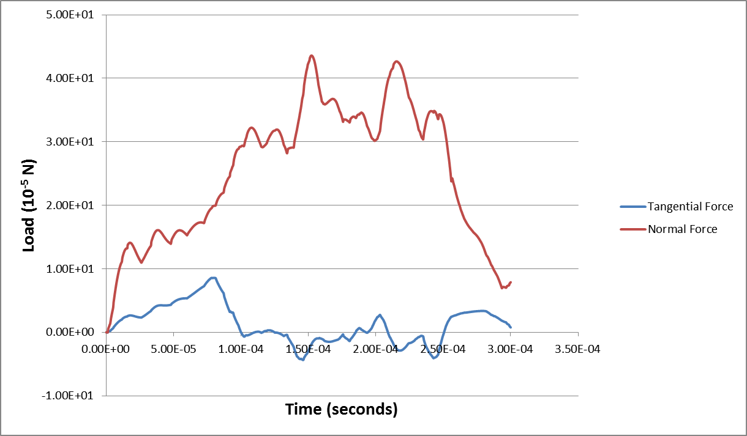

Figure 1: Transient load response (Intel Fortran compiler used).

The standard output results are contained in the $Home/mfix/pulverization/results folder.

1. References
2. [1] MFIX – Multiphase Flow with Interphase eXchanges, Version MFIX-2012-1, January 2012.   
   (The readme.pdf is distributed within the MFIX tar ball.)